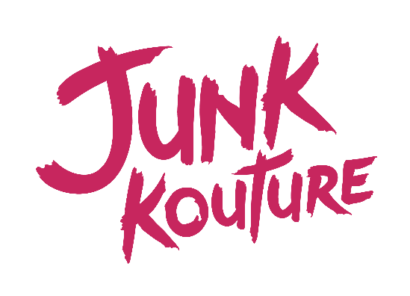

Junk Kouture Complaint Form:
(This should be completed by an educator/school rep on behalf of a participant)
- Your details
Full name:
Email address:
Address:
Contact number:
Please state which of the above methods you would like us to contact you: _________________
If our standard way of dealing with complaints is difficult for you, please let us know so that we can discuss how we might help you.
The person who experienced the problem should normally fill in this form. If you are filling this in on behalf of someone else, please fill in section 2. Please note that before taking forward the complaint we will need to satisfy ourselves that you have the authority to act on behalf of the person concerned.
- Making a complaint on behalf of someone else: their details
Their full name:
What is your relationship to them?
Why are you making a complaint on their behalf?

- About your complaint
What do you think we did wrong, or failed to do?
____________________________________________________________________
Describe how you personally or the person you are representing suffered or has been affected
______________________________________________________________________________
______________________________________________________________________________
What do you think should be done to put things right?
___________________________________________________________________________
Have you already contacted our team on any other medium? i.e., social media or email?
_____________________________________________________________________________
If you have any documents to support your concern/complaint, please attach them with this form.
________________________________________________________________________________
Signature:
Date:

